Quorum Data & AI (QDAI) Platform – CTO Contract Support Discussion – EPAM
Goal of this Engagement
The goal of this engagement is to establish:
- Introductions of Meeting Participants – Round Table
- Current State
- Forward Path
- Where We Are Going
- How Quorum Operates
- Engagement Expectations

Current State
Current Organization
Quorum operates in a Product-Led Segment Model broken into 4 groups that fall under our Chief Product & Technology Officer – Radhika Krishnan.
3 Product Segments
- North America O&T
  - Product Leadership – Sonali Singh
  - Engineering Leadership – David Williams
  - Segment CTO – Corey House
- Upstream Planning
  - Product Leadership – Chit Patel
  - Engineering Leadership – Chaminda Peries
  - Segment CTO – James Feek
- International O&T
  - Product Leadership – Ale Gajewski
  - Engineering Leadership – Eoghan O’Neill
  - Segment CTO – Svein-Helge Kallevik
Spans All 3 Product Segments
- Office of Product Technology & Innovation (OPTI)
  - Global Operations – Flower Pledge
  - Strategy & Corporate Development – Chris Giufredda
  - Office of the CTO – Corey House
    - Data Architect - Shawn Borkar
    - Distinguished Software Architect - James Feek
    - Sr. Director - AI Strategy – J.B. (Jonathan Birkhowitz)
  - Global Cloud Operations – Dan Kandersak

Organization
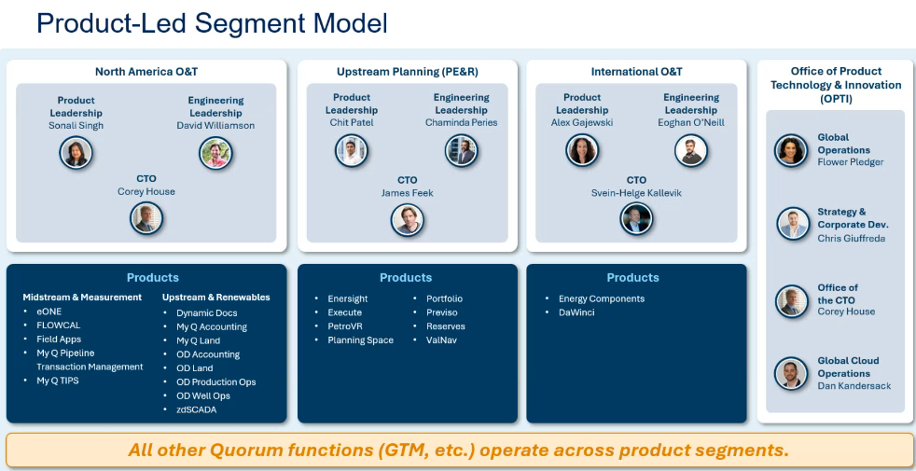
3 Segments and Product Portfolio
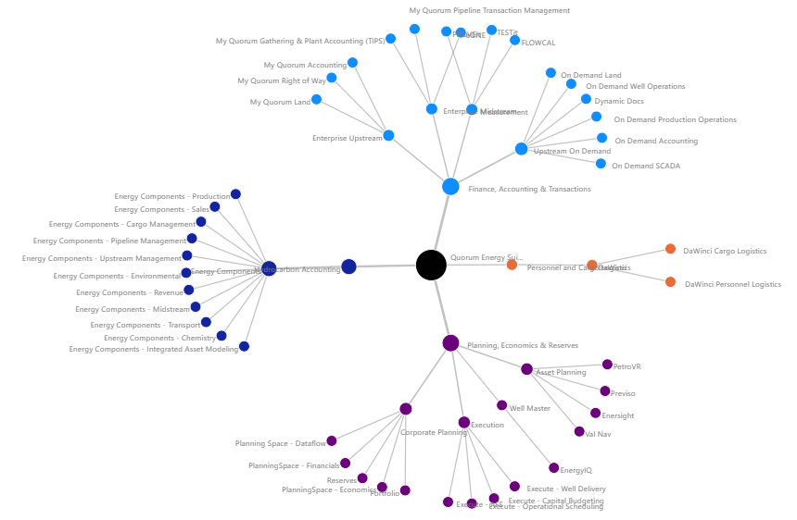

The Challenge We Are Solving (The "Why")
The current energy software landscape is fragmented and siloed systems. Traditional "Data Lakes" often become data graveyards which are static repositories that support retrospective reporting but lack the connectivity for modern AI. For our customers, this means:
- Inconsistent Insights: Data residing in disparate applications makes it difficult to get a single, trustworthy view of your operations.
- Slower Decisions: Lack of unified data limits your ability to generate comprehensive reports and inhibits true data-driven decision-making.
- Context-Poor Data: Data exists in disparate apps without the semantic links (e.g., linking a "Well ID" in Planning to "Royalty Obligations" in Land) needed for complex reasoning.
- The Sequential Handoff Gap: Innovation is slowed by manual handoffs between siloed systems, preventing real-time cross-functional visibility.

Forward Path
SaaS First Direction – Long Journey
While our long-term modernization strategy is focused on transitioning the entire product portfolio to a SaaS-first platform, this evolution will be a multi-phased journey. In the interim, we remain committed to delivering the data insights and intelligence capabilities our customers require to meet their immediate business needs.
Our Investment – Quorum Data & AI Platform (QDAI)
We are making a strategic investment in our technology stack to move beyond traditional data management toward Relational Intelligence. Our new Quorum Data-Centric Intelligence platform is designed to transform "Data Silos" into a unified Knowledge Graph. By mapping the complex relationships across the entire energy lifecycle, we provide the essential "nervous system" required to power autonomous, agentic AI and deliver deep, real-time insights that optimize your operations.
Our Mission: The Commitment
Our immediate mission is to collapse these silos by establishing a unified Data Ontology. This isn't just about moving data; it’s about defining the relationships between every data point in the Quorum suite. This "Relational Intelligence" serves as the fuel for Agentic AI, moving beyond basic chatbots to intelligent agents that can perform complex, multi-step tasks autonomously.
Our Vision: A Unified Data Platform (The "What")
Our ultimate vision is the transformation of Quorum’s data landscape into a Data & AI platform that provides:
- Self-Service Access & Productivity: Enable end users to instantly access and work with data as needed, driving significant improvements in end-user productivity.
- Refined Data Products for Value Creation: Deliver high-quality, consumable, and trustworthy data (acting as products) that can be readily leveraged both internally across Quorum product suite and shared externally with customers.
- Standardized Data Integration: Provide seamless, standardized data integration between Quorum products and standardized data integration for customer data platforms, simplifying the flow of data into your wider enterprise ecosystem.
- Holistic Reporting: Deliver enhanced cross-product reporting capabilities, moving beyond siloed views to gain a complete, integrated picture across all your Quorum products.
- Future-Ready AI & Interoperable Foundation: Establish a robust data foundation built on industry standards (OSDU/PPDM) to ensure Quorum intelligence integrates seamlessly with the wider energy ecosystem. This interoperability serves as the bedrock for deploying future AI capabilities, enabling you to unlock deeper insights, optimize operations, and lead industry data exchange efforts.
- A Domain-Specific Knowledge Graph: An interconnected understanding of your business that links land, production, and accounting into a single, living ecosystem.
- Agentic AI Workflows: AI that doesn't just "find" data but "reasons" through it—such as running full-lifecycle economics for a new lease by pulling dependencies across multiple silos.
- Refined Data Products: High-quality, "meat-on-the-bone" data that is ready for immediate use in both Quorum and your own enterprise AI models.
What This Means for Your Business: Driving Efficiency and Innovation
This transition is more than a technical upgrade, it represents a strategic commitment to maximizing your productivity and efficiency across the entire Quorum Product Suite as we strive to become your Indispensable Intelligence Partner. We are providing the "brain" that allows your data to work for you, to turn your insights into boardroom decisions.
Key Benefit | Direct Customer Impact
Unified Data Architecture | Enhanced Reliability & Insight: Achieve unparalleled consistency and accuracy across all products, leading to more reliable, data-driven decisions.
Unified Data Ontology | Unmatched Consistency: A single "source of truth" that bridges products like Land, Production, and Accounting, ensuring everyone speaks the same data language.
Seamless, Standardized Integration | Accelerated Ecosystem Connectivity: Enable faster, standardized data integration of refined Quorum data products with your existing enterprise data platforms and technology ecosystems.
Intelligent Operational Optimization with Agentic AI | Superior Productivity & Focus: Experience enhanced cross-product workflows and the rollout of AI-powered solutions. Deploy AI agents capable of executing complex, cross-silo tasks, freeing your team from manual data reconciliation.
Robust Data Foundation | Foundation for Digital Leadership: We are establishing a sophisticated data foundation with refined data products. This foundation is essential for supporting critical industry efforts such as OSDU, enabling advanced cross-product reporting, and driving future digital innovation within the energy ecosystem.
Relational Intelligence Engine | Context-Aware Decisions: Every well, lease, and dollar is linked, providing a holistic view that understands how one change impacts the rest of your lifecycle.

Our Best-in-Class Technology Foundation: Proven and Open (The "How")
To deliver this world-class solution, we are adopting a powerful, integrated data platform architecture built on technologies that are stress-tested and widely adopted by leading global enterprises. This approach leverages the power of open standards for reliability and flexibility.
Our core infrastructure leverages the Azure data platform ecosystem tech stack to power our open-source data platform, ensuring high performance, scalability, and robust security. Crucially, this architecture is designed to support multi-region deployment and multi-tenancy, guaranteeing global accessibility and isolated, secure environments for all customers.
- Databricks (Core Engine): Serving as our core engine for large-scale data transformation, AI, and governance. Databricks is an industry-standard platform that utilizes the open-source Delta Lake framework, the standard for building reliable, high-performance data lakes.
- Microsoft Fabric (Business Intelligence): Utilized for last-mile data publishing and integrated Business Intelligence (BI) reporting, leveraging its deep connection with tools like Power BI.
- Ontology/Knowledge Graph/Unified Semantic Layer (TBD-Under Investigation): The Unified Agentic Semantic Layer unifies Quorum’s disparate software products and legacy data sources by shifting the focus from raw data silos to a portable, Quorum-owned semantic world model. This is achieved through an integrated "Agentic AI Data Stack" that combines high-scale compute with a powerful Unified Semantic Layer powered by ADLS and Databricks.
This strategic combination ensures enhanced performance, deep integration within the cloud ecosystem, and multi-cloud flexibility to mitigate vendor lock-in risks. By choosing this modern, open architecture, we guarantee a scalable, reliable, and future-proof foundation for your data.
We are confident this new data platform will be the most significant enabler for unlocking unparalleled value from your energy data. We look forward to sharing our progress and future capabilities with you.
Reference Architecture Below
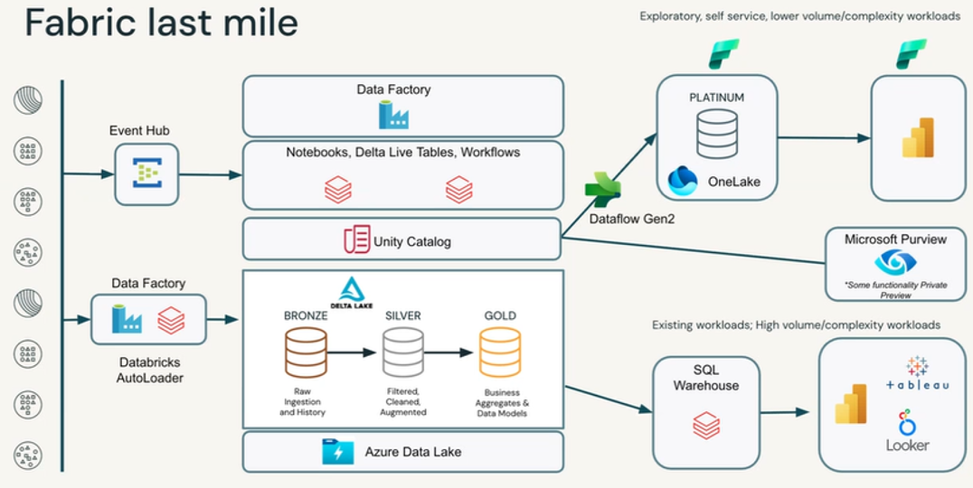
MDM Architecture Integration
Master Data Management (MDM) plan must focus on creating a "Single Source of Truth" for critical entities specifically Meters, Locations, and Products across your fragmented source systems (Ex. TIPS, QPTM, eONE, and FLOWCAL). In a Medallion Architecture, MDM lives primarily in the Silver Layer (Refined), where cross-system reconciliation occurs.
Component | MDM Function Description
Azure Purview | Catalog & Lineage: Track how a volume record from FLOWCAL was merged with TIPS data.
Unity Catalog | Access Control: Ensure only authorized users see the "Golden" master data vs. raw source data.
Databricks DLT | Data Quality: Enforce "Is_Exception" flags where master data attributes don't align.
Delta Sharing | Distribution: Share the "Golden Records" with customers ( Ex. Energy Transfer, Howard) via the Databricks Marketplace and/or Fabric API.

How Quorum Plans to Operate (TBD)
Metaphor: In a hybrid federated model, the Platform Solution Architect and 2 DevOps Data Engineers function as the "Control Tower" and the "Ground Crew," respectively. Together, they manage the infrastructure and laws of the airport (The Hub).
The Segment Architects and Product Teams function as the "Aircraft Design Engineers" and "Flight Crews" (The Spokes). They are responsible for designing, building, and piloting/operating the specific data product solutions the "Planes" that deliver business value. This ensures that while segments have the freedom to design custom aircraft for their specific missions, they must all use the same runway and follow the same flight patterns, specifically regarding how Quorum data enters and exits the ecosystem. Moreover, they are not allowed to design & build planes/solutions that the Airport/Platform does deem compatible with the Platform.
1. The "Control Tower/Air Traffic Controller” (Platform Solution Architect) Interface
The Platform Solution Architect is the ultimate technical authority on the Quorum Data & AI (QDAI) Platform's integrity. The architect reports to Shawn (Platform Data Architect, Data Platform PM, DevOps PM/PO) and interface with the larger org including Segment System Architects and Segment Product Teams for architectural signoff.
- Ingestion & Retrieval Strategy: The Architect defines the "Standard Ingress" (e.g., using Azure Data Factory and Private Links) for all Quorum products and work with each Segment/System architect to understand what is appropriate based on where it is hosted (QCloud, AWS, Azure). They determine if data is pulled via API, JDBC, or Change Data Capture (CDC), ensuring no segment creates a "rogue" connection that stresses Quorum hosted source systems nor QDAI Platform resulting in product downtime/disturbance.
- "Plane" Design Sign-off: In this model, a "Plane" is any data product or AI solution built by a Segment Team (e.g., a PE&R dashboard or a Midstream predictive model). Before a segment can move from "Dev" to "Prod," the Architect must sign off on the design to ensure it follows the Enterprise Architecture & Governance within Quorum and doesn't create a data silo.
- Interface with Segment Architects: They act as the "Supreme Court" for the Segment System/Software Architects. While a Segment Architect designs for local needs within the Product level architecture, the Platform Architect ensures those designs are compatible with the Quorum Data & AI Platform ecosystem.
2. The "Ground Crew" (DevOps Data Engineer) Interface
The DevOps Data Engineers are the primary technical touchpoint for the Embedded Segment Resources (The Spokes). They report to Shawn (Platform Data Architect, Data Platform PM, DevOps PM/PO).
- Executing the Ingestion Blueprint: Once the Solution Architect determines how Quorum data is ingested, the DevOps Engineer builds the automated, reusable pipelines to land that data in Bronze. This allows Segment Engineers to focus on the "Silver" and "Gold" transformations rather than the complexities of Quorum connectivity (unless DevOps Engineer need additional DevOps Data Engineer capacity for ingestion).
- Operational Guardrails: They report to Shawn (DevOps PO) to manage the platform backlog of work. If a Segment Team’s "Plane" (solution) is poorly designed and consumes too many resources, the DevOps Engineer is the one who identifies the bottleneck and enforces the Architect's standards.
- Infrastructure-as-Code (IaC): They provide the "Spokes" with the Terraform modules needed to spin up Azure services (Databricks or Synapse environments) that are pre-configured to retrieve data from the QDAI Platform securely.
3. Segment Team Roles (Aircraft Design Engineers and Flight Crew)
The "Spoke" innovators who design solutions for specific business needs (e.g., a PE&R dashboard or a Midstream AI model). They also operate the product from day to day.
- They own the Internal Design of the plane (the Silver/Gold logic and UI). While they have autonomy over the "cabin layout" (how the business views the data), they must ensure their "engines" are compatible with the Hub’s fuel (Quorum Data Standards) and their "radio" communicates on the Tower's frequency (Governance/Security).
- They "fly" the data from point A to point B. They take the raw materials provided by the Ground Crew (Bronze data) and pilot it through the necessary transformations (Silver to Gold) to reach the final destination: actionable business insights.
4. Operational Interaction Map
Interaction Point | Solution Architect Role (Control Tower) | DevOps Data Engineer Role (Ground Crew) | Segment Team Roles (Aircraft Design Engineers & Flight Crew)
Data Ingestion | Determines the secure protocol for each Quorum product (API vs. DB). | Builds and maintains the "Bridge" (ADF/Fabric/Databricks Data Pipelines) from Quorum Products to Bronze. | Requests specific new Quorum tables/objects through the DevOps PO (Shawn).
Data Retrieval | Defines the secure Access Control (Unity Catalog) and "Gold" layer standards. | Sets up the Private Endpoints and IAM roles for secure retrieval. | Queries the data to build segment-specific models and insights.
New Solution Build | Must Sign-off on the architecture to ensure it fits the QDAI ecosystem and meets Quorum security standards. | Automates the CI/CD pipeline the segment will use to deploy the solution.  Validates the code and infrastructure configuration before Prod deployment.  Ensures deployment checklist, documentation, and knowledge transfer videos have been created. | Designs and codes the solution ("The Plane") following the Architect's guidelines/guardrails.

4. Federated Accountability
Under this structure, the QDAI Platform Foundation (The Hub) maintains a "veto" power over the Segment Resources (The Spokes) to prevent the "Data Swamp."
- Uniformity: No Quorum product data is allowed into the platform unless it follows the Solution Architect's ingestion pattern.
- Stability: The DevOps Engineer ensures that "Run & Maintain" operations are centralized, so a failure in one segment's "Plane" doesn't crash the entire Quorum Data & AI Platform.
- Governance: Because the Solution Architect signs off on all designs, the organization is guaranteed that data retrieval is always compliant with the security standards.
Will provide more details on our operating structure when resources onboard.

Engagement Expectations
When searching for a data platform implementation partner, we need a team that's more than just a vendor/contractor, they need to be a true partner that acts as an extension of our own. They should bring a deep understanding of the entire data & AI platform lifecycle and how it can interact with a larger product portfolio, from ingestion to consumption, and act as a strategic advisor to enable data analytics, data integration, data science (AI/ML) use cases, data security, data governance across a diverse data & product portfolio landscape. Here are the key requirements you should expect from a partner to ensure a successful implementation of a data platform for example Microsoft Azure using Databricks.
Technical & Strategic Expertise
Our partner should be able to offer a comprehensive, end-to-end solution. This includes technical proficiency as well as a strategic, advisory mindset.
- Holistic Architecture and Design: They should be able to design a modern data platform architecture that is scalable, secure, and cost-effective. This involves more than just plugging components together; it requires an understanding of our business goals to create a customer specific blueprint that supports our long-term vision. This includes expertise in the Microsoft Azure ecosystem (Azure Data Lake Storage, Azure Data Factory, Azure Synapse Analytics, Azure Databricks, etc.) and how to best integrate it cost effectively for data processing and analytics keeping in mind long term product roadmaps with product teams and industry trends. This will also include enterprise architecture design patterns that integrate with the Quorum product landscape.
- Databricks Expertise: Look for a partner with deep expertise in Databricks, including Delta Lake for building a reliable lakehouse, Unity Catalog for centralized governance, and Databricks' capabilities for machine learning and data science. They should be able to build robust ETL/ELT pipelines and productionize data models.
- Data Governance and Security: The partner must be able to establish a robust data governance framework that covers data quality, lineage, and access controls including at the storage layer to any data transit outside of the platform (end to end encryption). Security is non-negotiable, so they should implement best practices for data encryption, network security, and identity management within Azure. This should be incorporated in their entire design and implementation.
- Infrastructure as Code (IaC): A high-quality partner will use IaC principles (e.g., using Ansible, Terraform, etc.) to deploy and manage our cloud infrastructure using CI/CD technology as code. This ensures consistency, reproducibility, and version control of our environment, preventing manual configuration errors and enabling rapid disaster recovery. This should be setup from the beginning using best practices. Developing standard practices for deployment across customers by working with Cloud Ops team to make sure ingestion patterns from Quorum products is standardize as much as possible.
- Continuous Integration/Continuous Deployment (CI/CD): They should implement CI/CD pipelines for our data and analytics solutions. This automates the process of building, testing, and deploying changes, leading to faster development cycles and fewer production issues.
Partnership & Engagement Model
The right partner treats our project as their own. Their engagement model should reflect this commitment to our success.
- Advisory-First Approach: The partner shouldn't just take orders. They should act as a strategic advisor, challenging our assumptions and goals, offering innovative solutions, providing guidance on how to maximize the value of our data, and look around corners to give you considerations with possible paths forward. This involves proactively identifying opportunities for improvement and anticipating future needs.
- Dedicated Project Team: Instead of a revolving door of contractors, you should expect a dedicated team with clearly defined roles and expectations, but should be able to self-organize to take on tasks and remove blockers as the project team progresses and encounters obstacles. They should have other experts internally within their organization who have already done corporate wide data platform implementations for other major clients, preferably industry. This provides a single point of contact and fosters a deep understanding of our business.
- Knowledge Transfer and Training: A key sign of a true partner is their commitment to making you self-sufficient. They should provide comprehensive documentation, training sessions, and hands-on guidance to empower our internal teams to manage and evolve the platform after the implementation is complete. This ensures you don't become reliant on them for every small change. They should be very disciplined in maintaining documentation for all work product and not slap something together before the project ends and leaves.
- Co-Engineer and Define Best Practices: Work with our teams to establish standards and best practices for data engineering, data science, and analytics on the new platform. This includes guidelines for data modeling, pipeline development, code reviews, and version control. They should also help define the roles and responsibilities within our future data team.
- Establish a Training Curriculum: Develop and deliver a structured training program for our employees. This goes beyond a simple handoff; it's a curriculum designed to upskill our data engineers, data analysts, and data scientists on the new tools and methodologies (e.g., Databricks notebooks, Delta Lake, Unity Catalog, and Azure services).
- Create a Community of Practice: Facilitate the creation of a cross-functional community within our larger organization. This forum allows your teams to share knowledge, discuss challenges, and collectively solve problems, ensuring that the platform's value is maximized across the company even upon their departure with them perhaps serving as an advisor after the project ends. The partner should provide initial guidance and mentorship to get this community started.
Tangible Deliverables
Our partner should clearly outline the tangible deliverables you will receive.
- Architecture and Design Documents: Comprehensive documents detailing the proposed architecture, data flows, security model, and technology stack.
- Working Codebase: All data pipelines, notebooks, and scripts should be well-documented, version-controlled (e.g., in Git), and adhere to best practices.
- Fully Deployed Platform: The complete data platform deployed using IaC, with all components configured and integrated.
- Operational Runbooks: Documentation outlining the day-to-day operations, monitoring procedures, and troubleshooting guides for the platform.
- Training & Handoff Materials: All materials necessary for our team to take ownership of the platform, including presentations, workshops, and user guides.

